Supplementary Figures 2
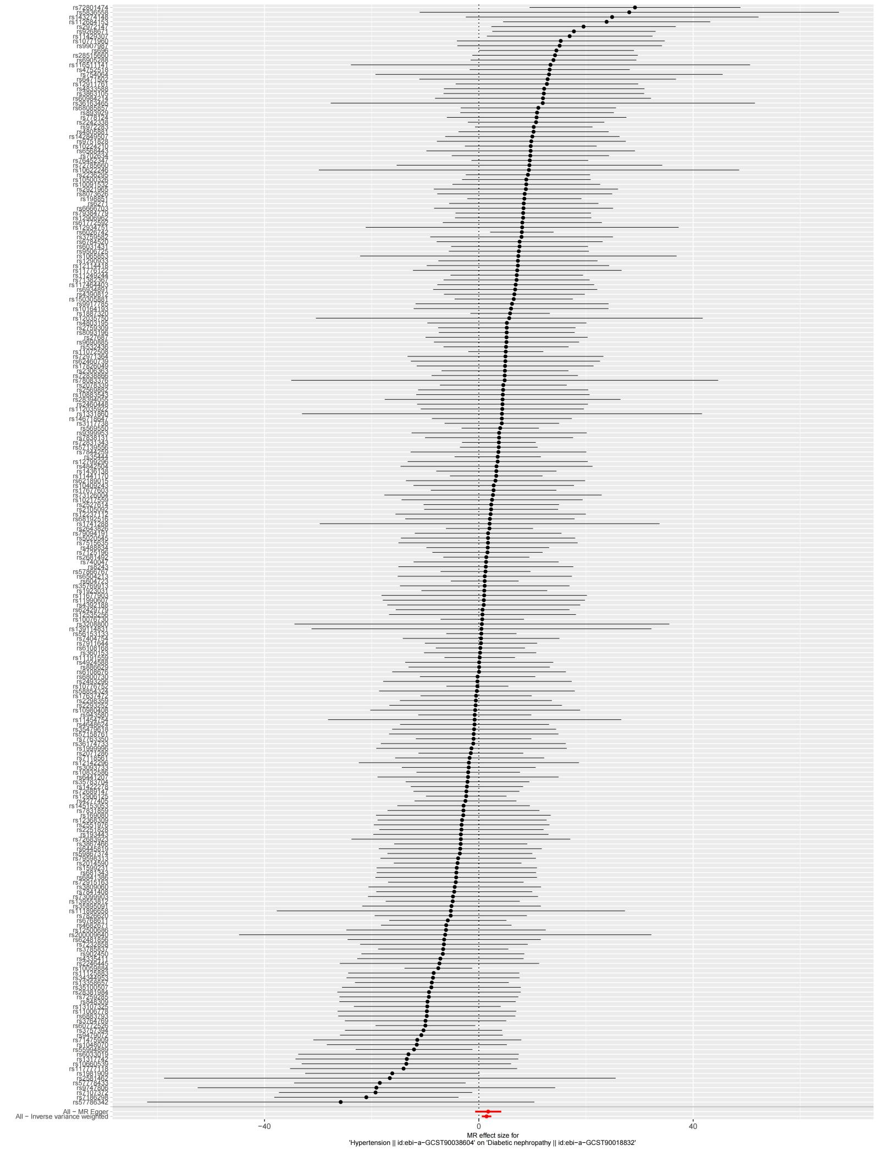
Plot 1: SNPs forest plot

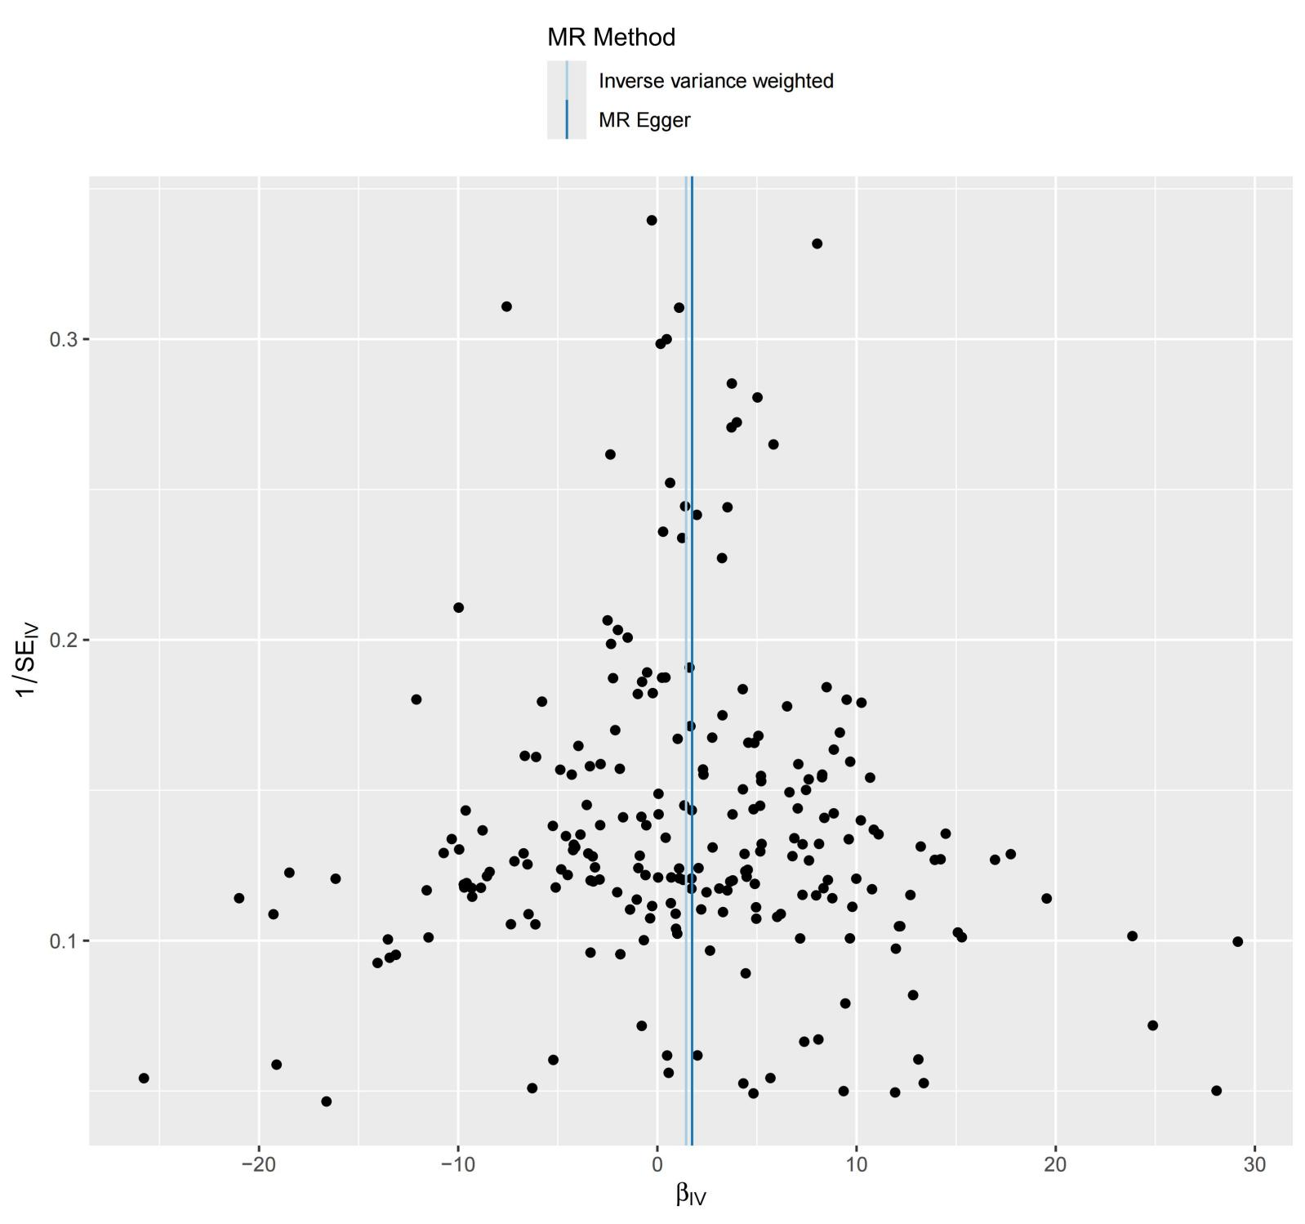
Plot 2: Funnel plot
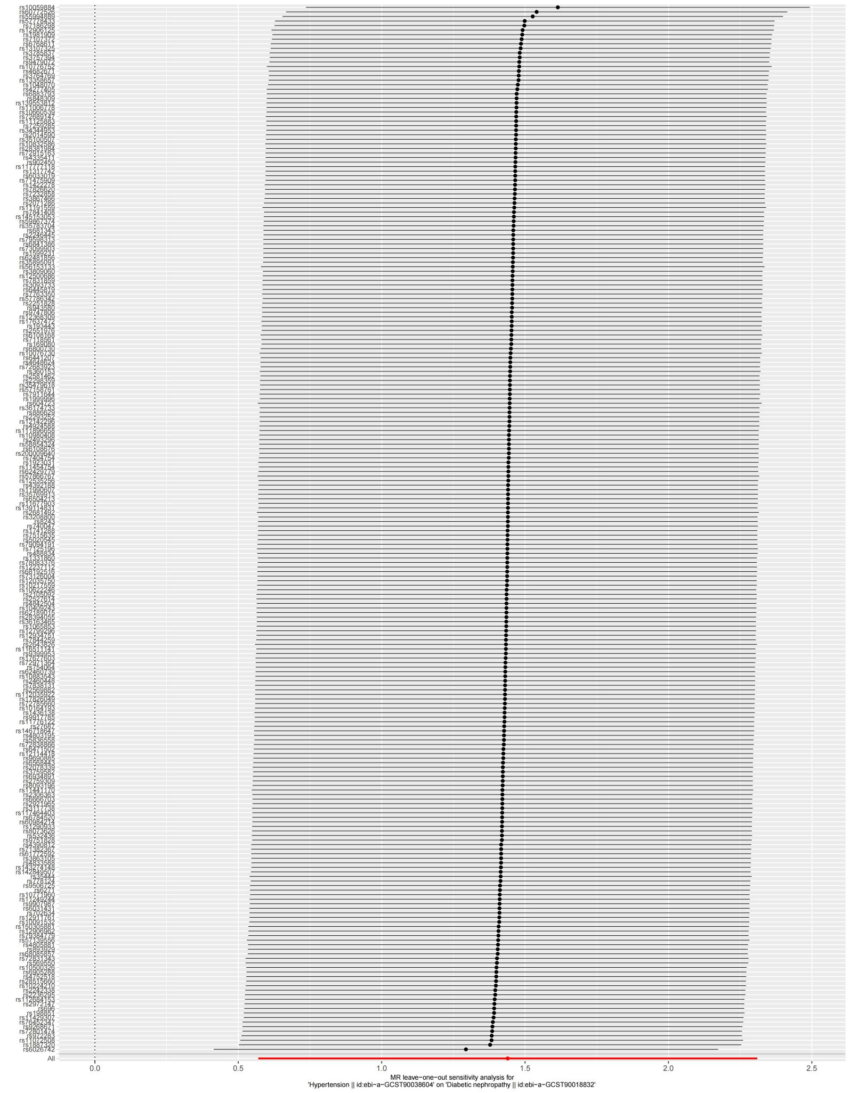
Plot 3: Leave-one-out analysis results

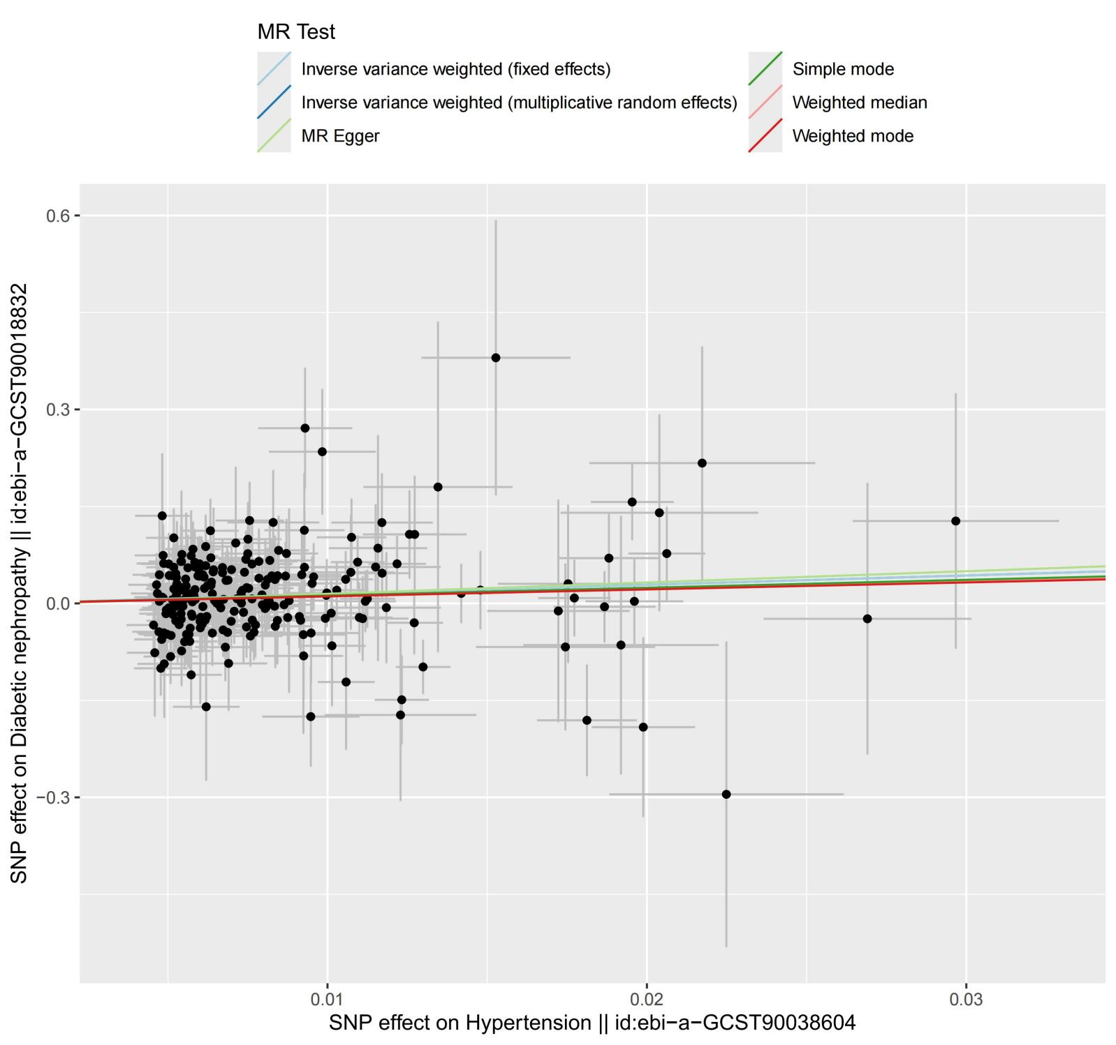
Plot 4: Scatter plot

